# Code Spectrum

## 1. Monotonic Function

| #include <bits/stdc++.h> using namespace std; int main() {  int x;  cin>>x;  int f = pow(x,3)+2*pow(x,2)+3*x+5;  cout<<f<<endl;  return 0; } |
| --- |

## 2. Seh Lenge Thoda

| #include <bits/stdc++.h> using namespace std;  int main() {  int n;  cin>>n;  vector<pair<int,int>> arr(n);  for(int i=0;i<n;i++) cin>>arr[i].first;    for(int i=0;i<n;i++) cin>>arr[i].second;    int sum=0;  for(int i=0;i<n;i++)  {  sum+=(arr[i].first*arr[i].second);  }  cout<<sum<<endl; } |
| --- |

## 3. Basant - The festival of roses

| #include <bits/stdc++.h> using namespace std; int main() {   int n,x;  cin>>n>>x;  vector<pair<int,string>> freshers(n);  for(int i=0;i<n;i++){  cin>>freshers[i].second>>freshers[i].first;  }  sort(freshers.begin(),freshers.end());  reverse(freshers.begin(),freshers.end());   cout<<freshers[x].second<<endl;  return 0; } |
| --- |

**Alternate Approach:**

| #include <bits/stdc++.h> using namespace std; int main() {   int n,x;  cin>>n>>x;  vector<pair<int,string>> freshers(n);  for(int i=0;i<n;i++){  cin>>freshers[i].second>>freshers[i].first;  }  sort(freshers.begin(),freshers.end());   cout<<freshers[n-x].second<<endl;  return 0; } |
| --- |

## 4. Despo Raju

| #include <bits/stdc++.h> using namespace std; int main() {   int q;  cin>>q;  while(q--){  int n;  cin>>n;  string s;  cin>>s;  long long int swaps=0;  int countOne=0;  for(int i=0;i<n;i++){  if(s[i]=='1'){  countOne++;  }  else{  swaps+=countOne;  }  }  cout<<swaps<<endl;  }  return 0; } |
| --- |

## 5. Lalit in Trouble

We need to find maximum number of overlapping classes at any instant.

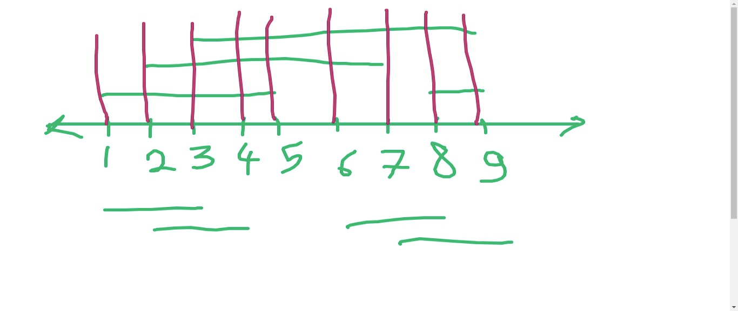

We can consider the overlapping classes at the start and end-times. No need to consider all the points on number line.

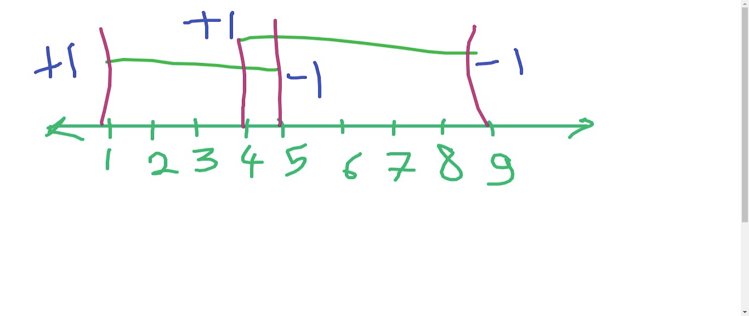

First, take a variable for counting overlapping segments, cnt=0

When u find a start time of any class, just increase cnt by 1.

When u find a end time of any class, just decrease cnt by 1.

And when calculating cnt, also store the maximum number of overlapping segments as the answer.

| #include <bits/stdc++.h> using namespace std; int main() {  int n;  cin>>n;   int s,f;  vector<pair<int,int> > vec;  for(int i=0; i<n; i++)  {  cin>>s>>f;  vec.push_back({s,+1});  vec.push_back({f,-1});   }  sort(vec.begin(), vec.end());  int cnt=0; // number of overlapping classes/intervals  int ans=0; // max. no. of overlapping classes/intervals  int sz=vec.size();    for(int i=0; i<sz; i++)  {  cnt=cnt+vec[i].second;  ans=max(ans,cnt);  }  cout << ans-1 <<'\n';  return 0;  } |
| --- |

## 6. Raju Bhai and Group Photo

**Naive Idea (Brute Force Approach):**

Go through all possible subarrays and if sum is divisble by x, update ans as maximum size of subarray.

| #include <bits/stdc++.h> using namespace std; int main() {  int n,x;  cin>>x>>n;    vector<int> vec(n);  for(int i=0; i<n; i++)  {  cin>>vec[i];  }    int ans=0;    for(int l=0; l<n; l++)  {  for(int r=l; r<n; r++)  {  long long sum=0;  for(int i=l; i<=r; i++)  {  sum+=vec[i];  }  if(sum % x == 0)  {  ans=max(ans, r-l+1);  }  }  }    cout<<ans;   return 0; } |
| --- |

Time Complexity: O(N3)

In general, you can perform 107 - 108 operations in 1 second.

Here, in worst case, N = 105 => N3 = 1015 . **So, it gives TLE.**

**A fast or optimised approach:**

For every prefix, store the prefix sum mod x.

This prefix sum will always lie between [0, x-1].

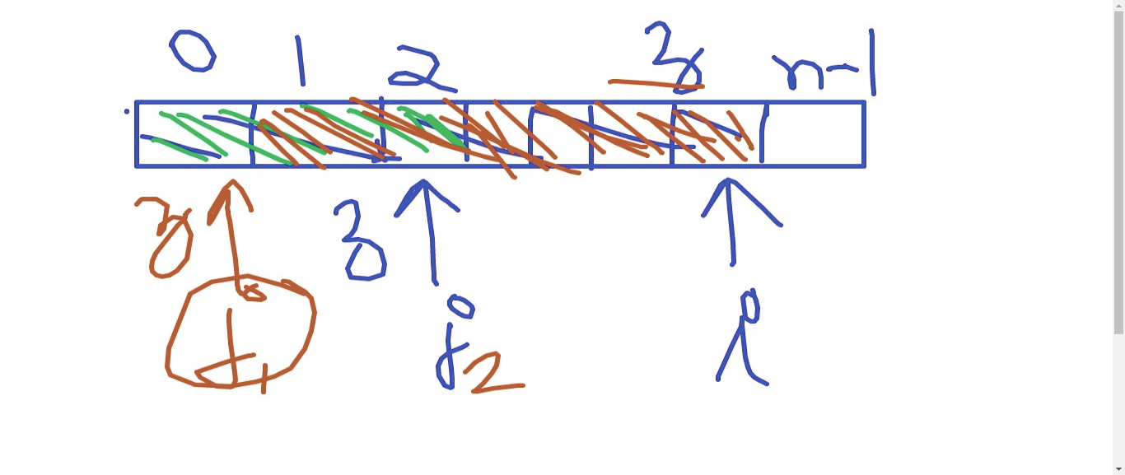

1. If for any prefix ending at index i, if there exists any prefix ending at j ( j<i ) and pref[i] == prefix[j], then the subarray from [j+1, i] should be divisible by x.

2. Suppose there are 2 or more than 2 such possible values of j, satisfying the above criteria, then I need to consider only the smallest value of j.

| #include <bits/stdc++.h>  using namespace std;   int main() {  int n,x;  cin>>x>>n;    vector<int> vec(n);  for(int i=0; i<n; i++)  {  cin>>vec[i];  }    vector<int> low(x);   // low[y] = The smallest value of j,   // such that sum of prefix ending at j mod x = y    for(int i=0; i<x; i++)  {  low[i]=-1; // -1 indicates no such prefix is available  }    int sum=0;  int ans=0;   for(int i=0; i<n; i++)  {  // (a+b)%x = ((a%x) + (b%x))%x   sum=((sum%x)+(vec[i]%x))%x;  if(low[sum]!=-1)  {  int j=low[sum];  ans=max(ans, i-j);  }  else  {  low[sum]=i;  }   if(sum%x==0)  {  ans=max(ans, i+1);  }  }    cout<<ans;    return 0; } |
| --- |

**Time Complexity:** O(n) + O(x) = O(max(n,x))

**Follow Up:** What if x<=109?

The problem is you can't create such a large array.

(Use map)

## 7. The Endgame

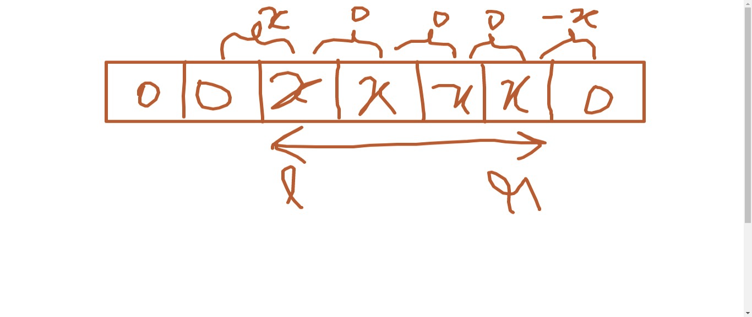

If we build a **difference array** diff, (an array containing difference of consecutive elements),

If we need to increase all elements of the given array in range [L, R], then in difference array, we need to make only 2 changes:

1. Increase diff[L] by x

2. Decrease diff[R+1] by x

Now, each of the p operations can be performed in O(1) .

For all p operations, time complexity is: O(p)

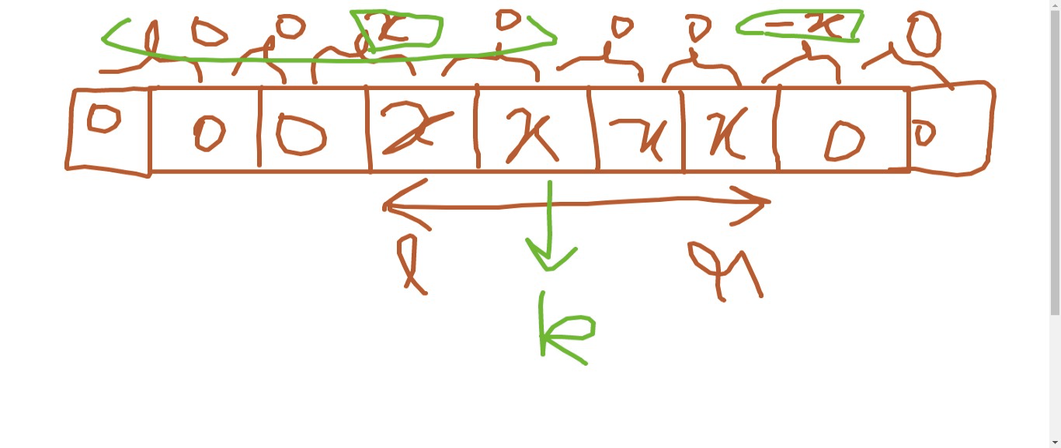

To find arr[k], just find the prefix sum of the difference array upto kth  index.

Now, the problem is, we can't create a difference array of size 109

(Because, you can create integer arrays of size 106-107)

- Use map and give an id to all the unique elements   
(Since, there are <= 103 distinct elements)

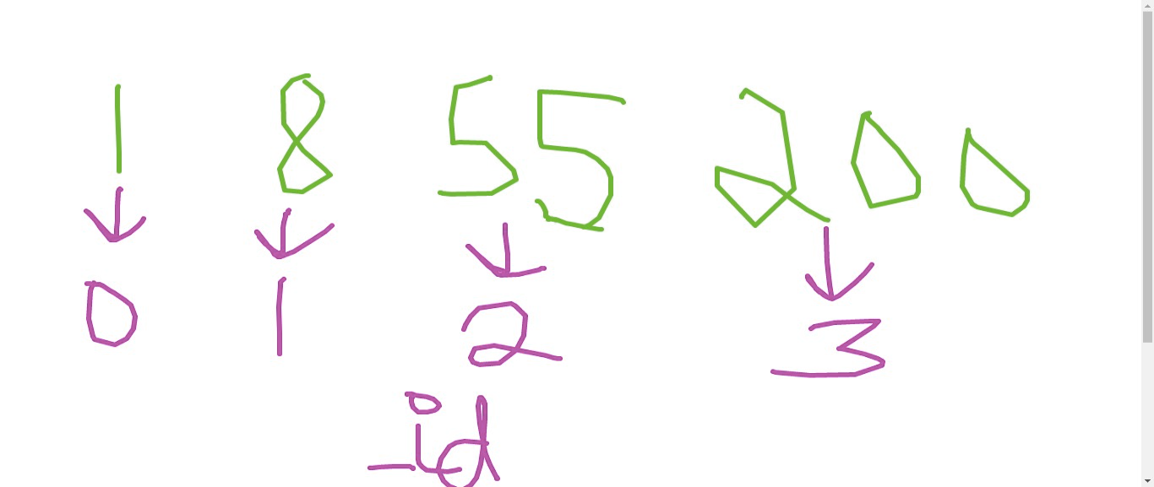

- See Setter's code in Editorial

**Follow Up:**

Suppose, there was no such constraint on distinct values of l and r. Then, how would you approach ?

- You use a map and use lower_bound()

See from here:

1. lower_bound() in vector: <https://www.geeksforgeeks.org/upper_bound-and-lower_bound-for-vector-in-cpp-stl/>

2. lower_bound() in map:

<https://www.geeksforgeeks.org/map-lower_bound-function-in-c-stl/>

- See tester's code in Editorial